**PROGRAM GAJI LEMBUR**

**Program**

1. **Program**

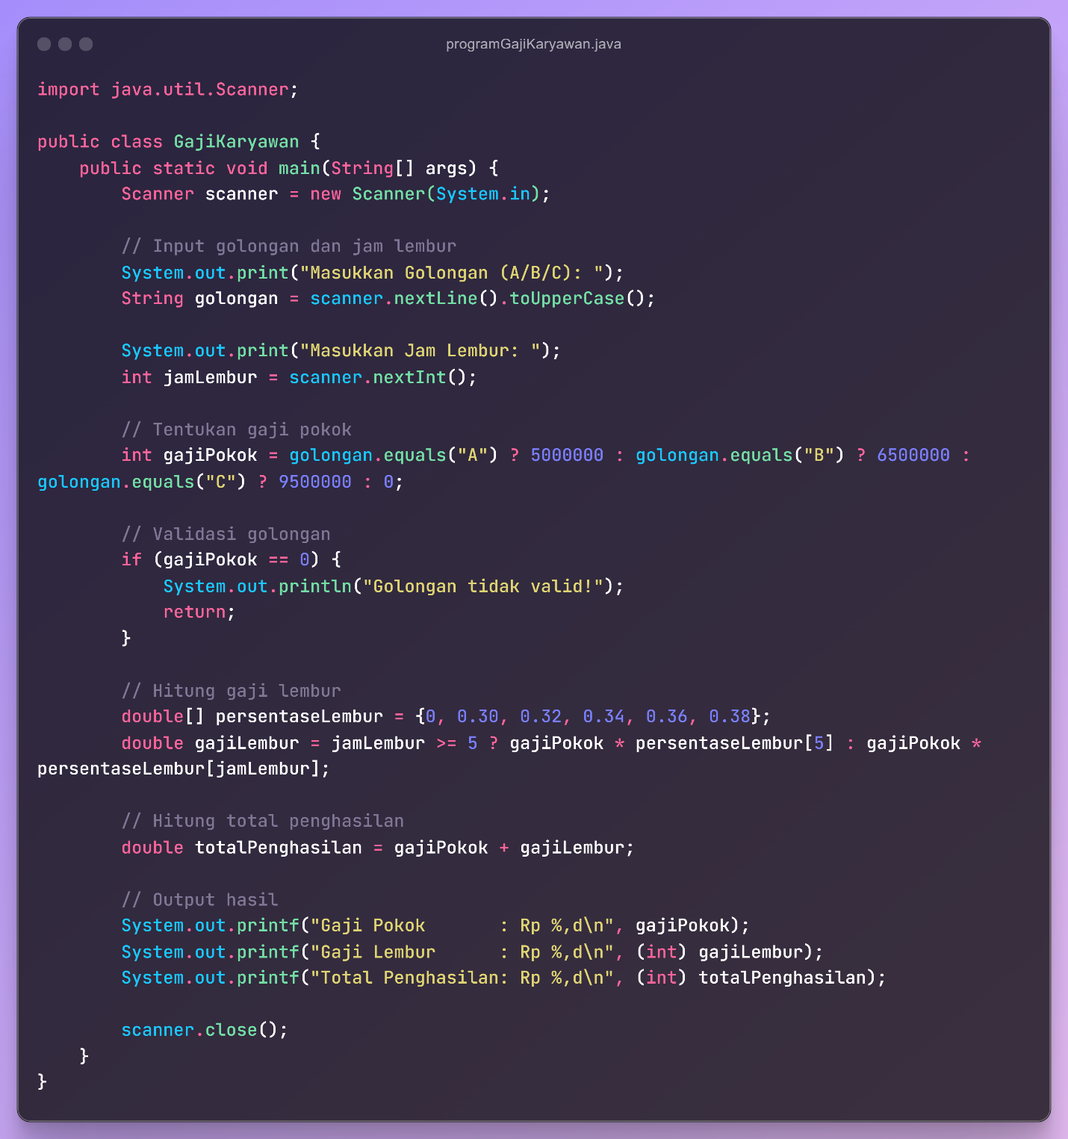

<https://codeshare.io/ezpXJL>

1. **Terminal**

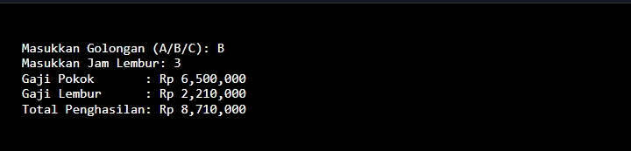

1. **Video**